Edge Delivery Services: Document-Based Authoring Lab Session

Hands-On Experience with Lightning-Fast Publishing

# Lab Session Structure

* Setup Edge Delivery project (Content Authors & Developers)
* Publish / Preview content – Sidekick (Content Authors & Developers)
* Utilizing Google Docs for authoring content.( Content Authors & Developers)
* Create new page and preview/publish (Content Authors & Developers)
* Create new block (Developers)

# Prerequisite

* Github account
* Google account
* Understand basics of HTML, CSS & JavaScript
* Node/npm installed for local development (only for Devs)

# Participant Takeaways

* First-hand experience with the entire content lifecycle—draft, review, approve, and publish—without leaving the document editor.
* Understanding how Edge Delivery Services and document-based authoring combine to drive digital experience innovation.
* How to apply different styles

# Steps to setup Edge Delivery Services project|

* Create new repo using use this template option   
   Repo - <https://github.com/adobe/aem-boilerplate>

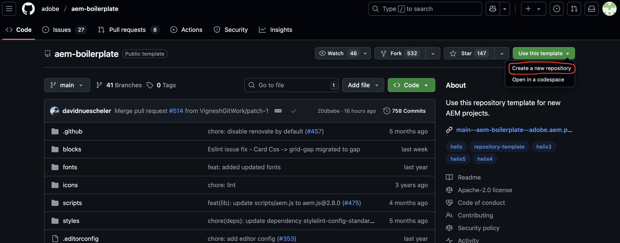

* Click the Use this template button and select Create a new repository, and select the user org that owns the repository  
    
  A screenshot of a computer

  AI-generated content may be incorrect.
* Install the [AEM Code Sync GitHub App](https://github.com/apps/aem-code-sync) on your repository by visiting this link: <https://github.com/apps/aem-code-sync/installations/new>  
    
  A screenshot of a computer

  AI-generated content may be incorrect.
* Copy the started content to your Google Drive
* Share docs with [helix@adobe.com](mailto:helix@adobe.com)
* Use your own Google Drive. Update Google Drive path in fstab.yaml configuration file  
    
  A screenshot of a computer

  AI-generated content may be incorrect.

# AEM Sidekick to preview or Publish

* Install the Sidekick Chrome extension using <https://chromewebstore.google.com/detail/aem-sidekick/igkmdomcgoebiipaifhmpfjhbjccggml>

* Pin the extension to make it easier to find it.

* To set up the Chrome extension, go to your previously shared Google Drive folder and click the extension icon in the browser toolbar and select Add this project  
    
  A screenshot of a computer

  AI-generated content may be incorrect.
* you are now ready to preview and publish your content from your Google Drive.
* Open the index doc file and make some changes. Activate the Sidekick by clicking on your pinned extension and you can preview or publish the content.

# For Content Authors : Create new Page

* Go to your google drive and create a new file. Right click and click on Google Docs.   
    
  A screenshot of a computer

  AI-generated content may be incorrect.
* Click on create and share

* Name the file to myProfile
* Create default content (write any free text).
* Default content – styles (H1, H2..etc.,)  
    
  A screenshot of a computer

  AI-generated content may be incorrect.
* To add a new section or block/component simply use 3 hyphens or horizontal line(click on insert option-> Horizontal line)  
    
  A screenshot of a computer

  AI-generated content may be incorrect.

* Preview the content using sidekick
* Publish the content

# For Developers : To get started with development.

Install the aem-cli plugin and check out the code repository

npm install -g @adobe/aem-cli

git clone [https://github.com/<owner>/<repo](https://github.com/%3cowner%3e/%3crepo)>

From there change into your project folder and start your local development environment using the following.  
  
cd <repo>

aem up

This opens http://localhost:3000/ and you are ready to make changes.

Test your changes locally and then follow the standard process to push the code.

Exercise :

Create a new block (profile).

Copy the code from <https://github.com/sarathraju/skillUp/tree/main/blocks/profile>

Amend changes in your project and add new styles